Day 14
1. Create a linked List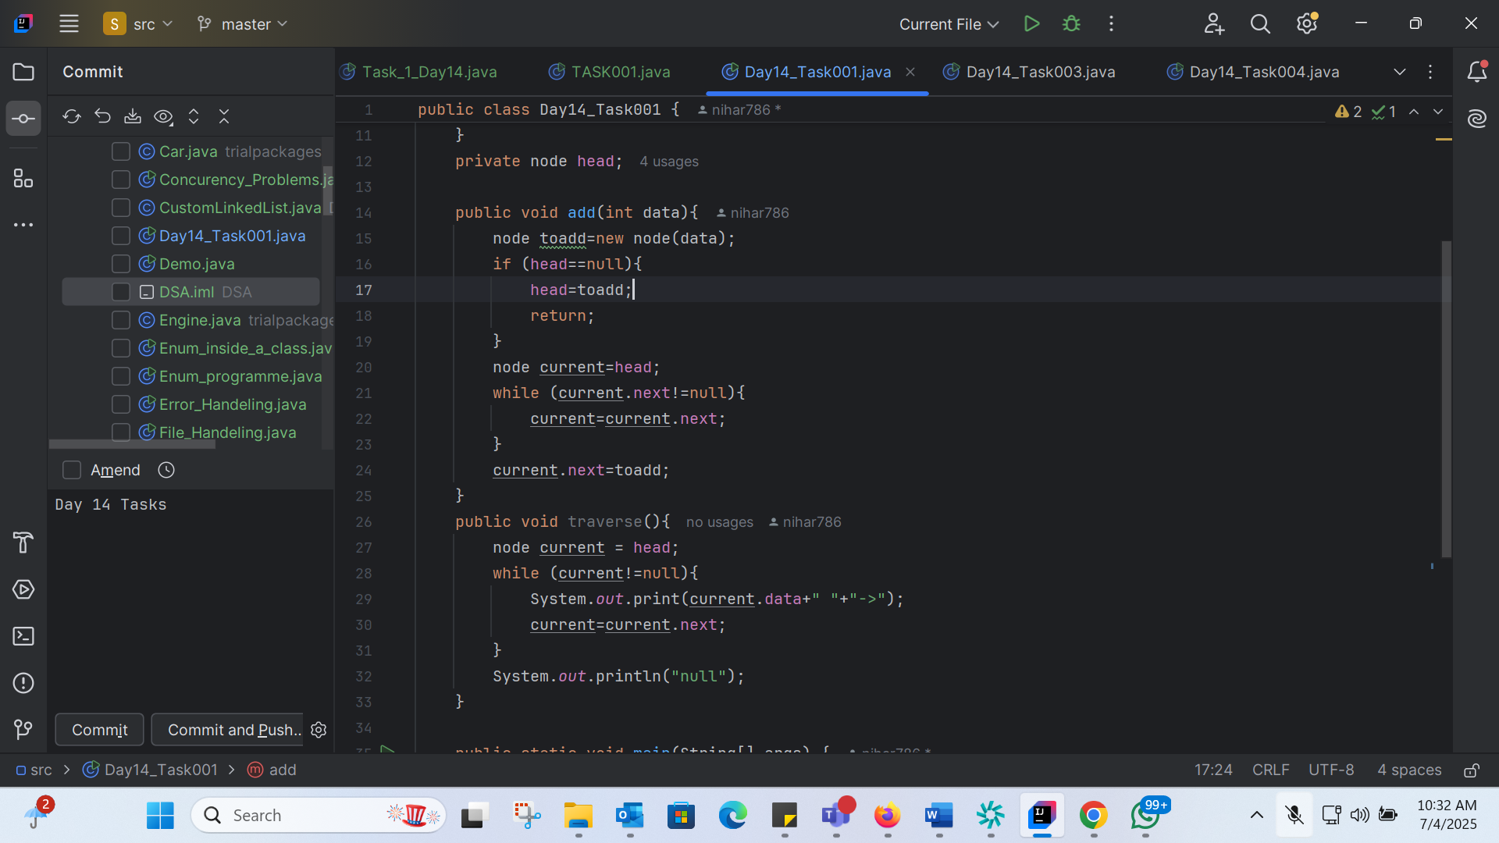
2. What do you understand by traversing a linked list?

Traversing a linked list means going through each item in a list one by one, starting from the first item and moving to the next until you reach the end.
Think of it like a train with many cars. Each car represents a node in the list, and traversing the list is like moving from one car to the next, visiting each car in order.
When you traverse a linked list, you can:

- Look at the data in each car (node)
- Do something with the data (like add it up or print it)
- Move to the next car (node) in the list

Traversing a linked list is like a step-by-step process that helps you work with the data in the list.

3. Create a Circular Linked list using Task 1 Singly linked list/ doubly linked list.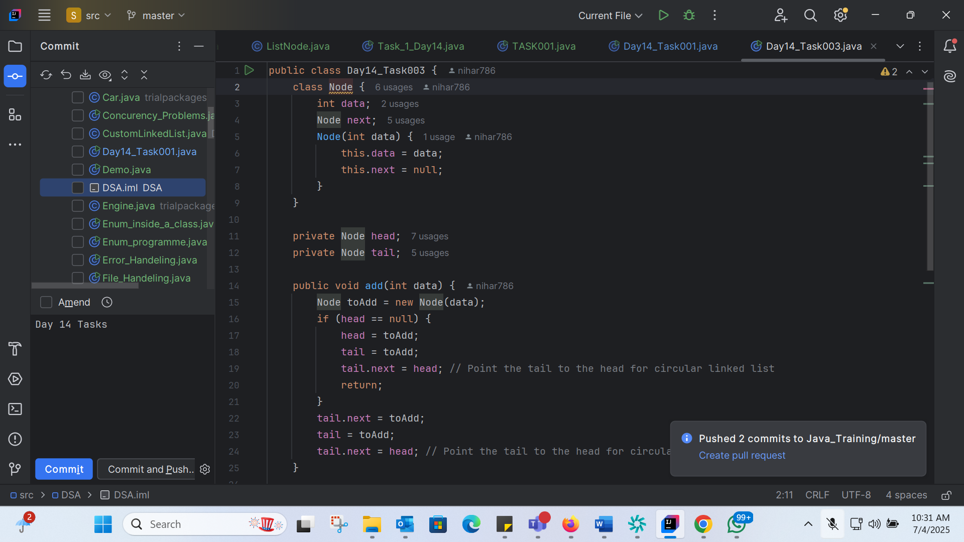
4. Delete a node in the circular linked list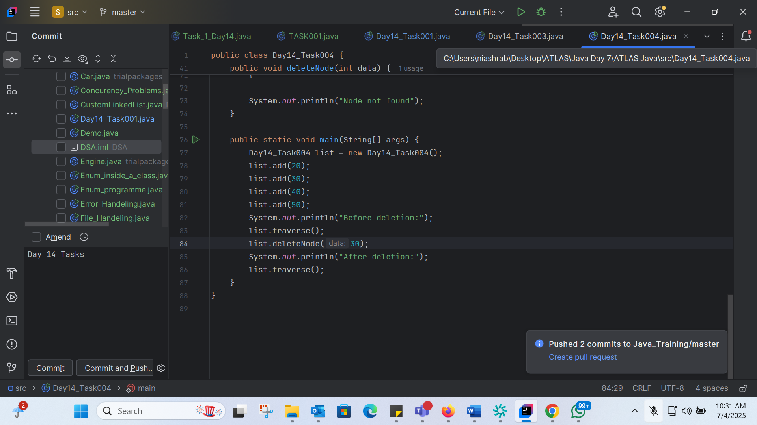
5.Push and POP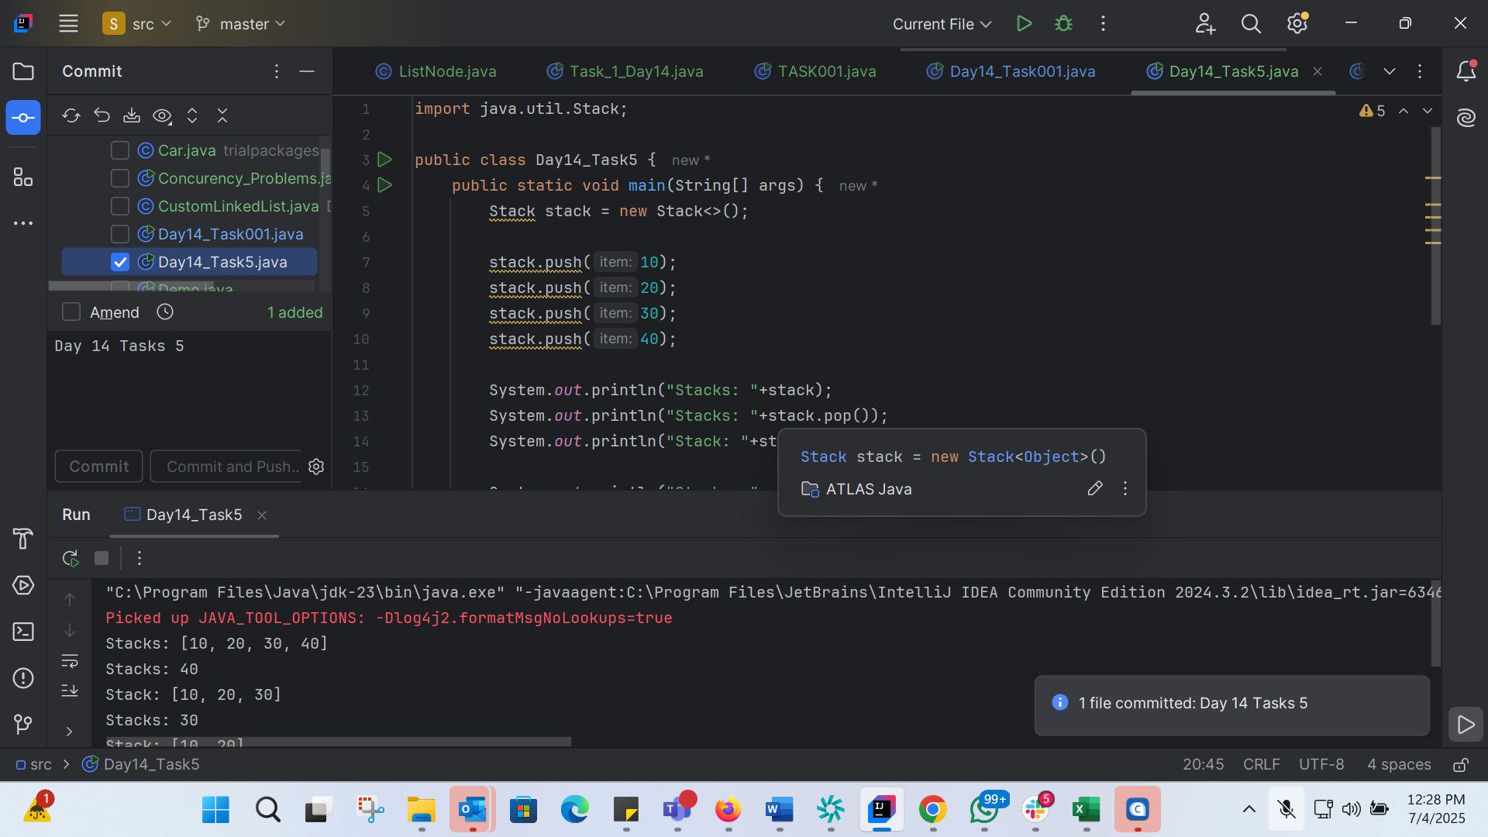
6. Find an element in the stack and display the position
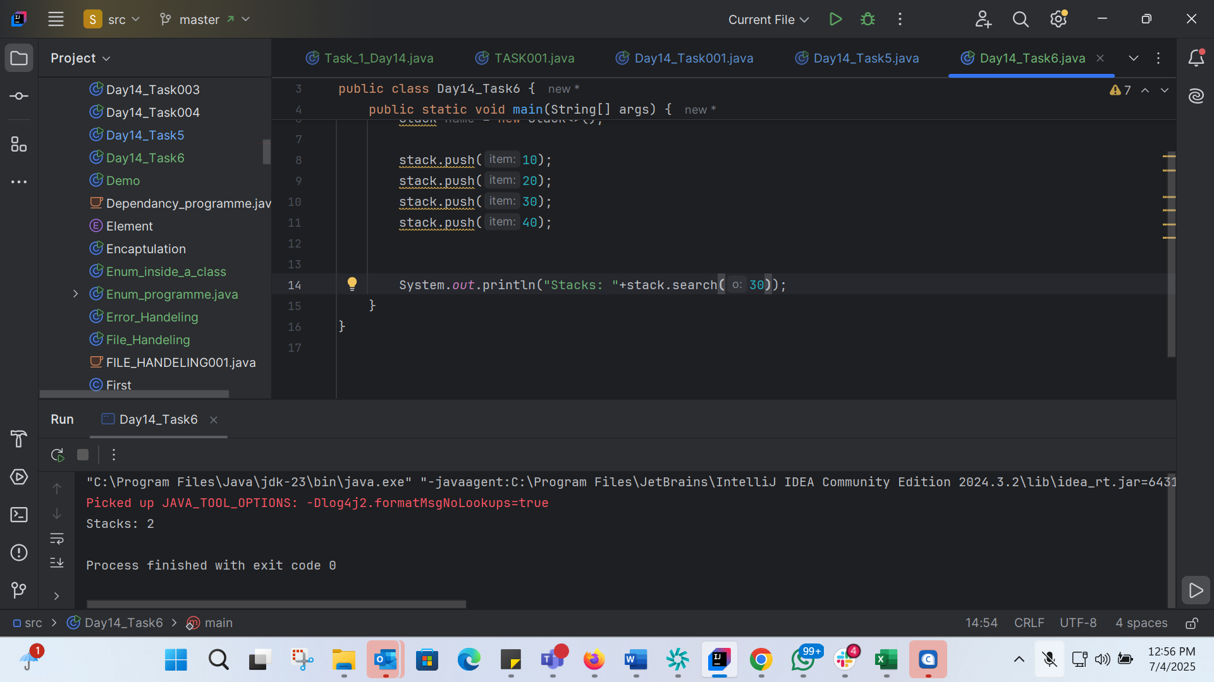
7. Peek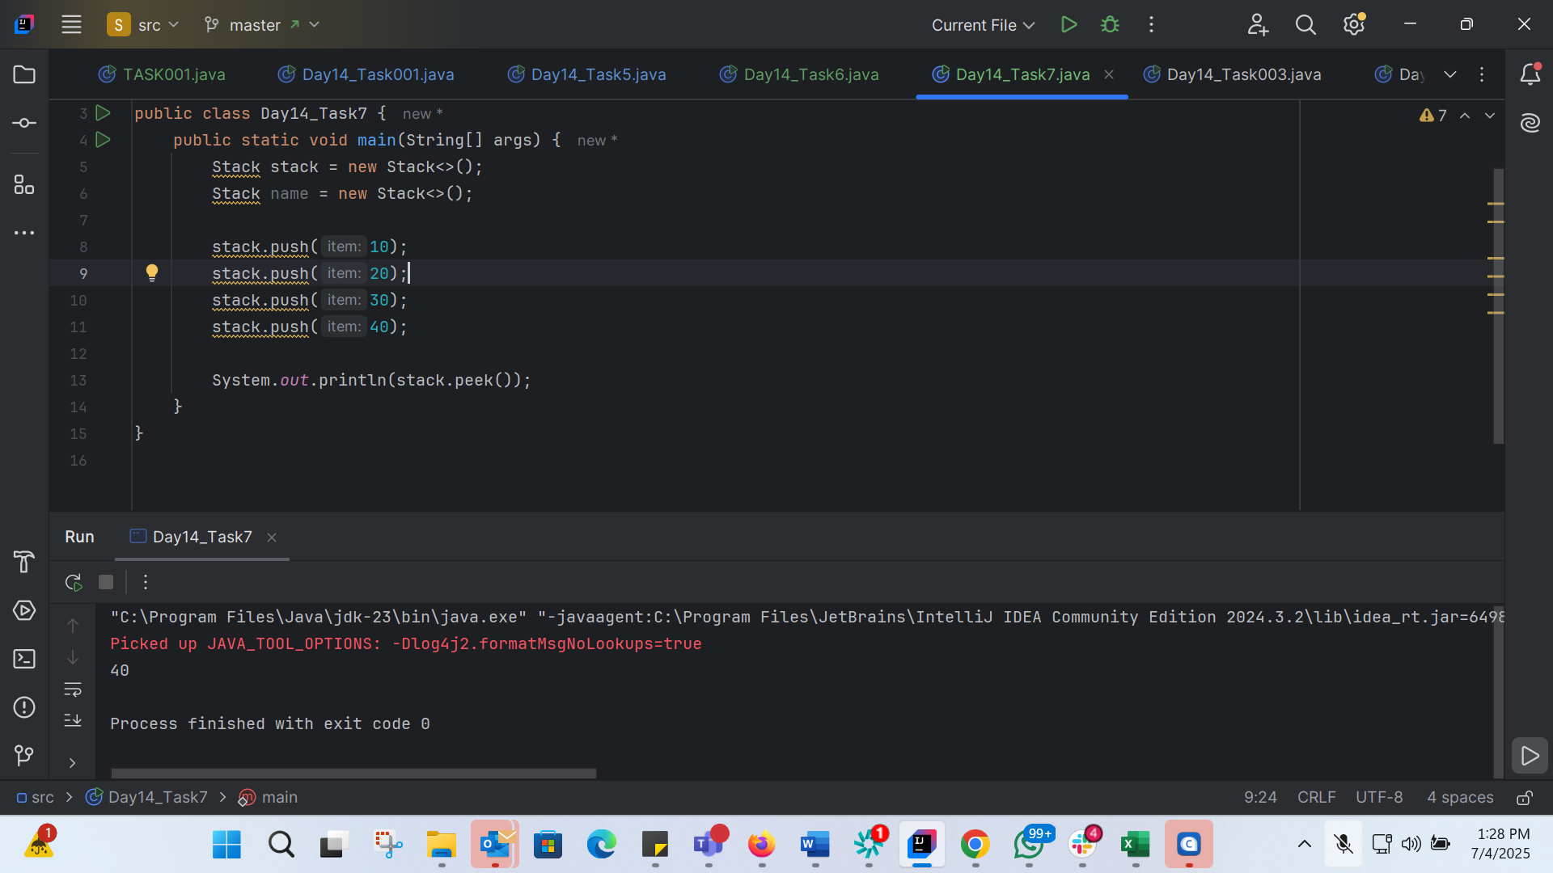
8.is empty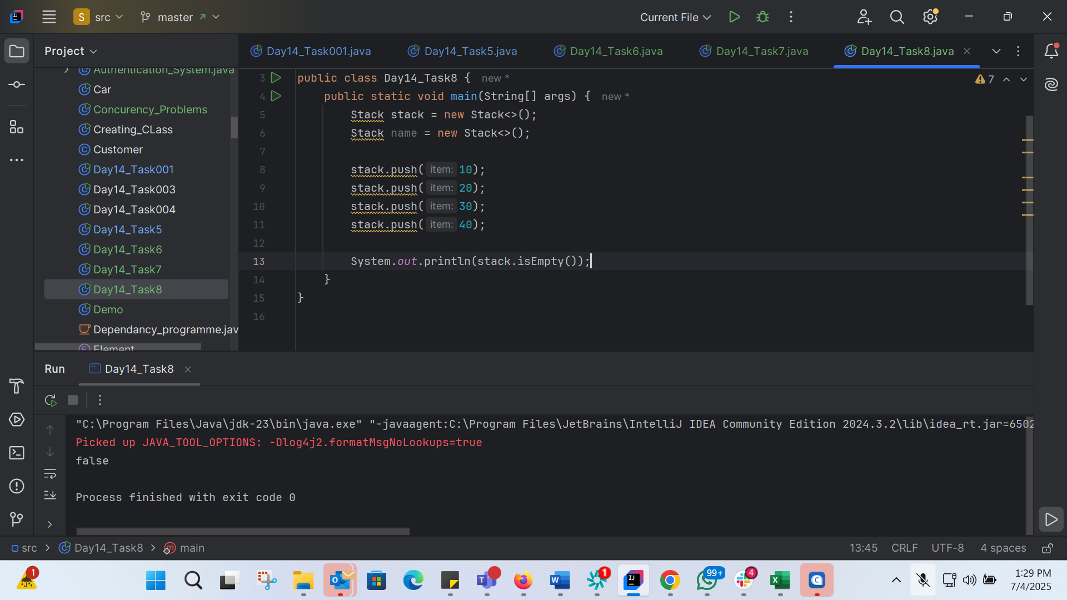
9. What are the methods of the stack class.. List them down.. With a one liner..
- push(E item): Adds an element to the top of the stack.
- pop(): Removes the top element from the stack and returns it.
- peek(): Returns the top element from the stack without removing it.
- empty(): Checks if the stack is empty.
- search(Object o): Searches for an element in the stack and returns its distance from the top.

10. 